**Strategies for Implementing Automation Successfully in Your Manufacturing Plant**

**Introduction**

Across the world, manufacturers are betting big on industrial automation. According to research, the [global industrial automation market](https://www.sphericalinsights.com/press-release/industrial-automation-market) is anticipated to register a compound annual growth rate (CAGR) of 8.84% and grow to $441.7 billion by 2030. This growth is driven by many factors, including the volatility of the market, disruptions in global supply chains, and the evolving needs of customers. The use of automation in manufacturing plants paves the way for faster results and less reliance on skilled resources, a challenge many industries currently face.

The constant developments in automation technologies, rising adoption of IoT devices and AI on the factory floor, and accelerating time-to-market demand also act as major factors driving the growth of the industrial automation industry.

Source: [Markets and Markets](https://www.marketsandmarkets.com/Market-Reports/factory-industrial-automation-sme-smb-market-541.html)

Embracing advancements in automation offers a great way for manufacturers to streamline processes, reduce errors and delays, and keep operations lean, efficient, and productive. It also allows manufacturers to improve asset performance while allowing the business to run with agility and resilience.

In this whitepaper, we will shed light on

* The continued adoption of automation in manufacturing
* The challenges of effective implementation
* The top automation strategies to embrace

**The Continued Adoption of Automation in Manufacturing**

In today’s dynamic and volatile business environment, [manufacturing businesses](https://www.gartner.com/en/digital-markets/insights/2024-tech-trends-in-manufacturing) are struggling to find qualified talent (35%), acquire new customers (35%), and train and upskill employees (34%). This has led to the continued adoption of digital technologies such as automation, artificial intelligence, business analytics, and more. Digital technologies empower manufacturers to streamline and scale up production, improve competitiveness, and drive the highest levels of efficiency.

**Key Manufacturing Trends**

Source: [Deloitte](https://www2.deloitte.com/us/en/insights/industry/manufacturing/manufacturing-industry-outlook.html)

Manufacturing automation tools deliver the ability to streamline workflows by removing manual errors and delays to keep operations lean, efficient, and productive. It helps build a competitive and resilient future while allowing companies to overcome evolving manufacturing challenges.

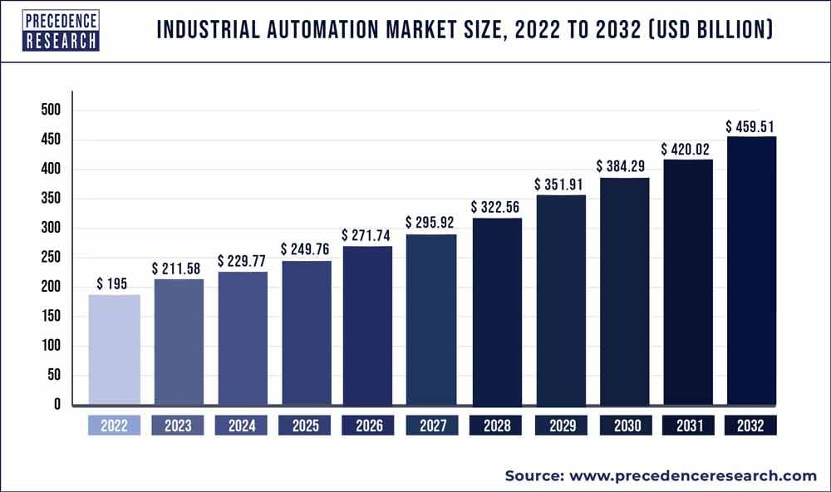

Source: [Precedence Research](https://www.precedenceresearch.com/industrial-automation-market)

**Top Automation Strategies to Embrace**

When it comes to driving manufacturing excellence, companies are looking to transform production processes via automation. Whether it’s building connected experiences or scaling to meet changing market demands, the impact of automation on manufacturing efficiency is massive. Yet, many IT leaders struggle to reap the true benefits of automation across the enterprise. This is because of a lack of strategic thinking and favor point solutions that address only a few urgent priorities.

Automation, if not implemented via a well-planned and well-executed strategy can result in a mountain of technical debt and a workforce that is stressed and frustrated. Not educating or training teams can ultimately undermine the company’s ability to quickly respond to shifting business conditions and changing customer expectations.

Depending on the current state of business processes, skillsets available, and future vision, manufacturing leaders should embark on the automation journey. They must assess their current automation maturity levels and embrace automation in a phased manner for sustained success.

Additionally, business leaders must embrace a range of strategies to enable automation successfully and centrally across their manufacturing setups:

1. **Needs Assessment**: In this digital age, embracing automation to boost efficiency is an obvious business priority. However, whether a manufacturing company can reap substantial profitability benefits from automating its processes depends a lot on the use case. There may be small companies that enjoy immense automation success and large companies at fail miserably with driving ROI from their automation investments.

Performing a comprehensive needs assessment is a critical first step that manufacturers must take to identify areas within the business that could be improved with automation. Such an assessment can help clarify what the business aims to achieve with automation and understand how it can help serve the bigger picture.

Having an experienced team of automation experts conduct an audit can help determine where automated solutions have the potential to drive efficiencies, cost savings, and bottom-line growth. Experts can do this in the context of individual business requirements and objectives. For example, if the business has major opportunities for automation but limited capital, experts can suggest embracing automation as a service to streamline costs while also ensuring maximum benefits.

1. **Technology selection:** Achieving automation success isn’t just about implementing a handful of tools across the manufacturing plant. According to a study by [Gartner](https://www.gartner.com/en/digital-markets/insights/2024-tech-trends-in-manufacturing), identifying the right technology (47%) and ensuring compatibility with existing systems (44%) are the biggest challenges manufacturers face when planning investments in new software. Given how complex and massive manufacturing operations can be, business leaders must evaluate and choose the right mix of automation tools.

Businesses must consider a wide range of modern automation tool options to tackle their projects. They must study the different types of automation and map them to their current processes to make the right decisions. From robotic process automation to business process management, chatbots to low-code applications, robotic arms to automated conveyors, pick-to-light processes to mobile robots, and more.

Being aware of the different automation technologies is vital to making the right tool selection. Since different technologies help achieve different objectives, such an assessment can help drive maximum ROI and results from automation investments. For example, manufacturers that handle large volumes of material can invest in automated conveyors to transport raw materials or semi-finished products at a precise time and to an exact location, thus improving efficiency, boosting accuracy, and ensuring the production line is operating efficiently.

1. **Partner selection**: Once business leaders have sufficient clarity on use cases and technologies, it is advisable to search for the right partner for the successful implementation of automation across the factory floor. Given how complex modern automation tools are, it is in the best interest of manufacturers to partner with an expert system integrator with a wealth of experience and expertise in automation technologies.

The right partner can streamline the highly complex process of designing and building an automated strategy suited perfectly for unique manufacturing requirements. A partner can work with the in-house IT team to fully coordinate and carry out a safe and successful integration plan. The right partner can also mitigate risks that come by, ensuring requirements are always met, timelines are stuck to, and future complications are avoided.

For instance, a partner can build or implement the right automated sortation system depending on the product type and business requirements. By automating the manual sifting, categorizing, and distributing of raw materials or finished goods, a partner can pave the way for greater efficiency in the distribution center operations, as well as establish flexibility for growth.

1. **Project Management:** Successful deployment of automation in the manufacturing plant also necessitates the need for effective project management. Since any automation project requires coordination and cooperation from different stakeholders, like hardware and software vendors, internal teams, and external stakeholders, streamlining project management is key.

Having a dedicated team of experienced project managers with experience in delivering digital projects globally is a great way to ensure proper implementation and management of the automation project. These project managers can also enable preventive management, rollout, and KPI management while also streamlining product management, monitoring, and user training.

For instance, a robust approach to project management can help in monitoring and tracking implementation progress, streamlining communication between stakeholders, and ensuring high levels of transparency and visibility. It can also aid in improving the overall quality of the automation project while managing budgets and timelines and mitigating project risks.

1. **Change Management:** Introducing automation into the manufacturing plant, although highly beneficial, also brings about several changes that need to be efficiently managed. Having a well-planned and well-documented change management strategy in place can go a long way in ensuring the long-term success of any automation project.

A robust change management plan and structure can aid in preparing people and processes for changes ahead. It can help in clarifying the reasons for the change, demonstrating the impact on day-to-day operations, and showcasing key successes so far.

Change management also helps create an environment where the workforce feels safe and secure. When implemented properly, it provides manufacturers with the opportunity to promote innovation, boost engagement, and gain competitive advantage within the industry.

**Leverage Automation to Build the Factory of the Future**

Automation is poised to play a significant role in helping manufacturers undertake the challenges they may face in 2024 and beyond. It allows them to cater to their persistent quest for efficiency and focus on building resilience across the organization. With 86% of manufacturing executives believing that smart factory solutions will be the primary drivers of competitiveness in the next five years, automation plays a crucial role in building the factory of the future.

As companies embrace the smart factory approach, the possibilities that automation presents are endless. From improving production efficiency to safeguarding worker safety, accelerating time-to-market to reducing costs --- automation allows teams to be faster, more agile, and more productive. By spending less time on repetitive tasks, business leaders can minimize human error and spend more time driving innovation.

Rapid advances in robotics, artificial intelligence, and machine learning are enabling machines to match or outperform humans in a range of complex and risky manufacturing activities. While most industry executives have already embraced automation, those who are just getting started, and those who have not yet begun need to embark on the journey on the right foot. Being aware of the opportunities and risks that automation brings is crucial to reap the benefits of this transformative technology.

**About QodeNext**

As a market leader in supply chain traceability technology, [QodeNext](https://www.qodenext.com/index.php) is uniquely positioned to help businesses harness the transformative potential of packaging automation. With our deep expertise in Industry 4.0 and cutting-edge, end-to-end solutions in the space, we help enterprises with the seamless implementation of automated solutions and the requisite support. Our teams work closely with leading hardware OEMs to create advanced solutions around traceability and automation, ensuring every iota of your packaging operations resonates with efficiency and precision.

With QodeNext, you get access to the expertise and solutions you need to future-proof your business and stay ahead of the curve. [Book a strategy call](https://www.qodenext.com/contact-us.php) to learn more about automation and how to create a more connected, efficient, and transparent supply chain that is ready to meet the challenges of tomorrow.